Washes: Used to bless or purify items or structures

4 Thieves Vinegar
The usual story declares that a group of thieves during a European plague outbreak were robbing the dead or the sick. When they were caught, they offered to exchange their secret recipe, which had allowed them to commit the robberies without catching the disease, in exchange for leniency. Another version says that the thieves had already been caught before the outbreak and their sentence had been to bury dead plague victims; to survive this punishment, they created the vinegar.
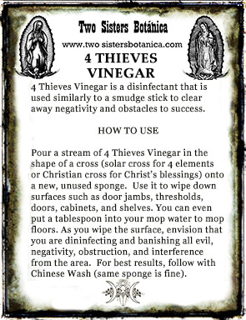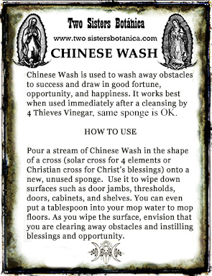

4 Thieves: Red Wine Vinegar base then add:
Garlic clove (1/3 or ½ is OK as well)
Choose 3 of the following: Lavender, Wormwood, Rosemary, Sage, Mint, Cinnamon, Clove, Nutmeg, Camphor, Cayenne, Wormwood, Black Pepper

Chinese Wash: Castile Soap base, then add:
3 unused broom straws
Choose from the following: Lemongrass oil or herb, 3-5 Frankincense tears, Epsom salts, VanVan oil.

Holy Water
Catch rain water in a copper receptacle, add silver and palo santo and allow to cure. Strain.

Sprays
Sprays have a vodka base. Rubbing alcohol can be used, but it is very difficult to overcome the isopropyl smell. Use the cheapest vodka you can find. The quality is not of concern in this process. We use mother bottles for sprays just as we do for oils.
Use enough oils to overcome any alcohol smell but be sure no to use too much oil or the product will be sticky and will stain fabric.
Be sure to strain the product so that no plant or resin matter goes into the spray bottle or it will clog the sprayer.

7 African Powers Spray - Love, Money, Luck, Health, Protection, Power, & Success
Frankincense x8, Myrrh x6, Cinnamon x4, Sage x2, Sandalwood x2, Dragon’s Blood x1

No More Monsters Spray
Rosemary, Juniper, Angelica, Copal, Lavender, Rose Hips, Dragon’s Blood, Chamomile, Lavender oil, Orange oil (half as much as lavender oil). Place in mother bottle to cure for a minimum of a week

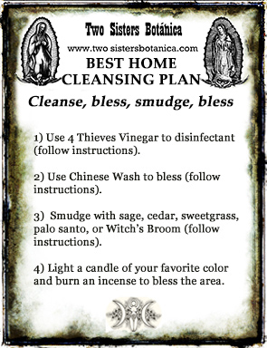
Florida Water
Citrus and floral smells to suit you

Cut & Clear Spray
1 part Peach, 3 parts Cucumber

Fiery Wall of Protection Spray
Equal parts of: Dragon’s Blood, Frankincense, Myrrh

Smudge Spray
Eucalyptus, Frankincense, Lemon, Fir Balsam, Rosemary, Cedarwood, Sage

